Chapter 7 Notes: User Input and while Loops

User Input (input())

What input() Does
- input() pauses the program
- Waits for the user to type something
- Stores the input as a string
message = input("Tell me something: ")
print(message)

⚠️ Important:
Everything from input() is a string, even numbers.

Writing Clear Prompts
- Always tell the user exactly what to enter
- Add a space at the end of the prompt

name = input("Please enter your name: ")
print(f"Hello, {name}!")

Multi-Line Prompts
You can build prompts using +=:
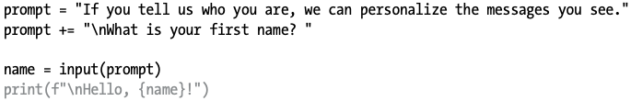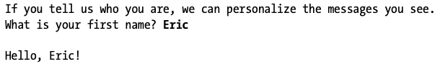

Converting Input to Numbers (int())

Why You Need int()
- input() returns a string
- You must convert before comparing or calculating

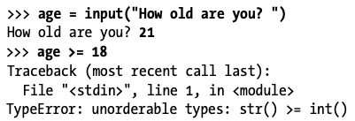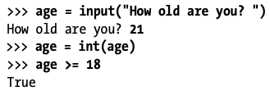

Modulo Operator (%)

What % Does
Returns the remainder of division
7 % 3 # → 1
6 % 3 # → 0

Even or Odd Example
number = int(input("Enter a number: "))

if number % 2 == 0:
print("Even")
else:
print("Odd")
while Loops

What a while Loop Does
- Runs as long as a condition is True

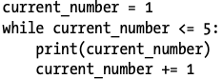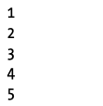

Letting the User Quit

Using a Condition
message = ""
while message != "quit":
message = input("Enter a message (or 'quit'): ")
if message != "quit":
print(message)
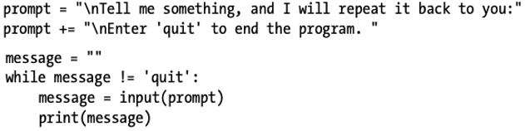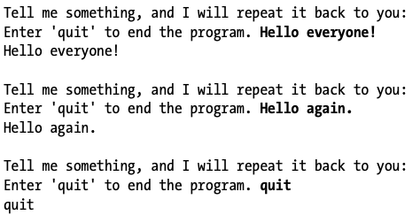

Using a Flag

What Is a Flag?
- A variable that controls when the program runs
- Useful when many conditions could stop the program.
- Usually True or False
active = True

while active:
message = input("Enter a message (or 'quit'): ")
if message == "quit":
active = False
else:
print(message)

break Statement

What break Does

To exit a while loop immediately without running any remaining code in the loop, regardless of the results of any conditional test, use the break statement. The break statement directs the flow of your program; you can use it to control which lines of code are executed and which aren’t, so the program only executes code that you want it to, when you want it to.

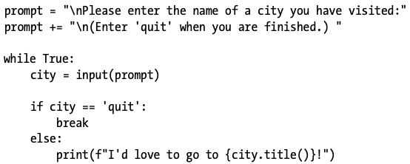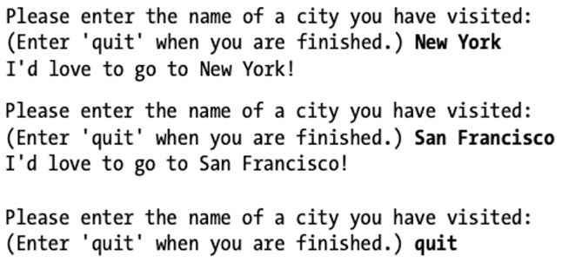

continue Statement

What continue Does

Rather than breaking out of a loop entirely without executing the rest of its code, you can use the

continue statement to return to the beginning of the loop based on the result of a conditional test. For example, consider a loop that counts from 1 to 10 but prints only the odd numbers in that range:

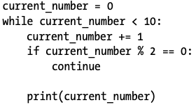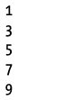

Avoiding Infinite Loops

Infinite Loop Example ❌
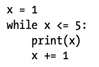

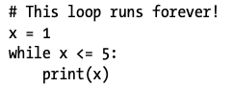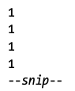

Using while with Lists

A for loop is effective for looping through a list, but you shouldn’t modify a list inside a for loop because Python will have trouble keeping track of the items in the list. To modify a list as you work through it, use a while loop. Using while loops with lists and dictionaries allows you to collect, store, and organize lots of input to examine and report on later.

Moving Items Between Lists

Consider a list of newly registered but unverified users of a website. After we verify these users, how can we move them to a separate list of confirmed users? One way would be to use a while loop to pull users from the list of unconfirmed users as we verify them and then add them to a separate list of confirmed users.

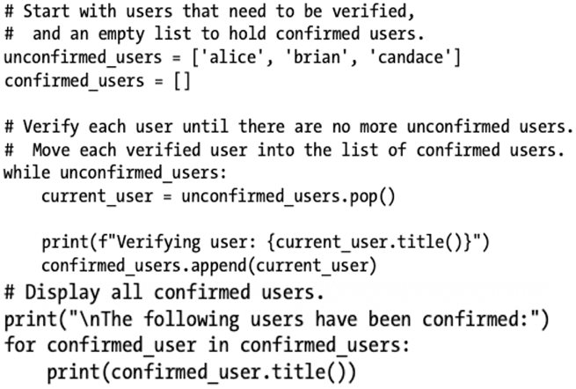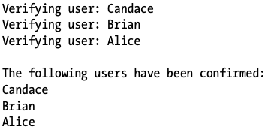

Removing All Occurrences
In Chapter 3 we used remove() to remove a specific value from a list. The remove() function worked because the value we were interested in appeared only once in the list. But what if you want to remove all instances of a value from a list? Say you have a list of pets with the value 'cat' repeated several times. To remove all instances of that value, you can run a while loop until 'cat' is no longer in the list, as shown here:
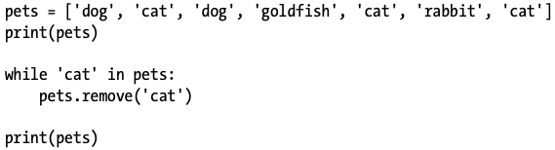

Using while with Dictionaries

Filling a Dictionary with User Input

You can prompt for as much input as you need in each pass through a while loop. Let’s make a polling program in which each pass through the loop prompts for the participant’s name and response. We’ll store the data we gather in a dictionary, because we want to connect each response with a particular user:

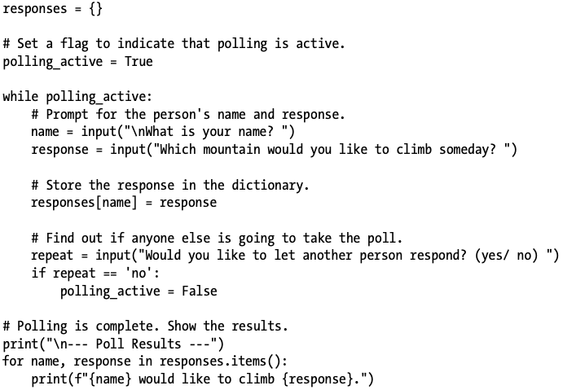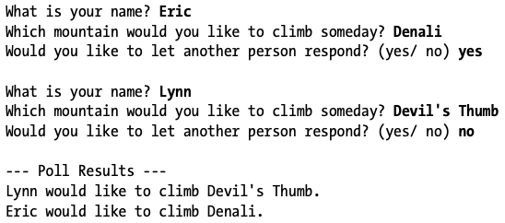

Key Takeaways (Memorize These!)
- input() → always returns a string
- Use int() for numbers
- while runs until condition becomes False
- break → exit loop immediately
- continue → skip to next loop iteration
- Use while when modifying lists
- Flags make complex loops clean and readable

